SECTION 093000 - SHEET MEMBRANE WATERPROOFING
- GENERAL
This specification includes the sheet membrane used as waterproofing and vapor retarder, in conjunction with tile and dimension stone installations. The content of this section should be combined with the specification for the tile and stone finishes including the setting materials required to complete the sheet membrane installation.
      - SUMMARY
Typical Floors and Walls: ValueSeal® sheet membrane may be installed for waterproofing on floor and wall substrates for tile and dimension stone installation.
Acceptable Floor Substrates: Concrete, cured mortar bed, plywood, and backer board.
Acceptable Wall Substrates: Concrete, masonry, backer board, and mortar bed.
Acceptable Backer Boards: See TCNA recommendations and ANSI standards.
        - Section Includes:
          - Sheet membrane waterproofing for [tile] [and] [dimension stone] installations.
The next three paragraphs describe ValueSeal used as waterproofing for floors and walls in showers, tub surrounds, and other wet areas.
            - Sheet membrane bonded to tile substrate with NobleBond EXT or latex Portland cement mortar, thin-set mortar for shower floors [and walls].
            - Sheet membrane bonded to tile substrate with NobleBond EXT or latex Portland cement mortar for walls at tub surrounds.
          - Sheet membrane waterproofing and water vapor retarder for [tile] [and] [dimension stone] installations.
The paragraph describes ValueSeal used as waterproofing and vapor retarder for steam room floors, walls, and ceilings.
            - Sheet membrane bonded to tile substrate with latex Portland cement mortar for steam room floors [and walls].
      - REFERENCES
        - ANSI A108.13 - Installation of Load Bearing, Bonded, Waterproof Membranes for Thin-Set Ceramic Tile and Dimension Stone.
        - ANSI A118.10 - American National Standard Specifications for Load Bearing, Bonded, Waterproof Membranes for Thin-Set Ceramic Tile and Dimension Stone Installation.
        - ASTM E96/E96M - Standard Test Methods for Water Vapor Transmission of Materials.
        - ASTM F1869 - Standard Test Method for Measuring Moisture Vapor Emission Rate of Concrete Subfloor Using Anhydrous Calcium Chloride.
        - ASTM F2170 - Standard Test Method for Determining Relative Humidity in Concrete Floor Slabs Using in situ Probes.
        - TCNA Handbook - TCNA Handbook for Ceramic, Glass, and Stone Tile Installation.
      - ACTION SUBMITTALS
        - Product Data: For each specified product.
        - LEED Submittals:
Include the next paragraph for LEED NC, LEED CS, and LEED for Schools.
          - Certificates for Credit MR 5: For regional materials, indicating location of manufacturer and point of extraction, harvest, or recovery. Include distance to project, cost, and fraction by weight for regional components.
Include the next paragraph for LEED CI, only.
          - Certificates for Credit MR 5: For regionally manufactured [and regionally extracted and manufactured] materials indicating location of manufacturer [and point of extraction, harvest, or recovery]. Include distance to project, cost, [and fraction by weight] for regional components.
Include the next paragraph for LEED NC, LEED CI, and LEED CS.
          - Data for Credit IEQ 4.1: For [adhesives] [and] [sealants], statement of VOC content.
        - Shop Drawings:
Include details sheet membrane waterproofing installation, with flashings and terminations.
      - INFORMATIONAL SUBMITTALS

Field quality-control reports.
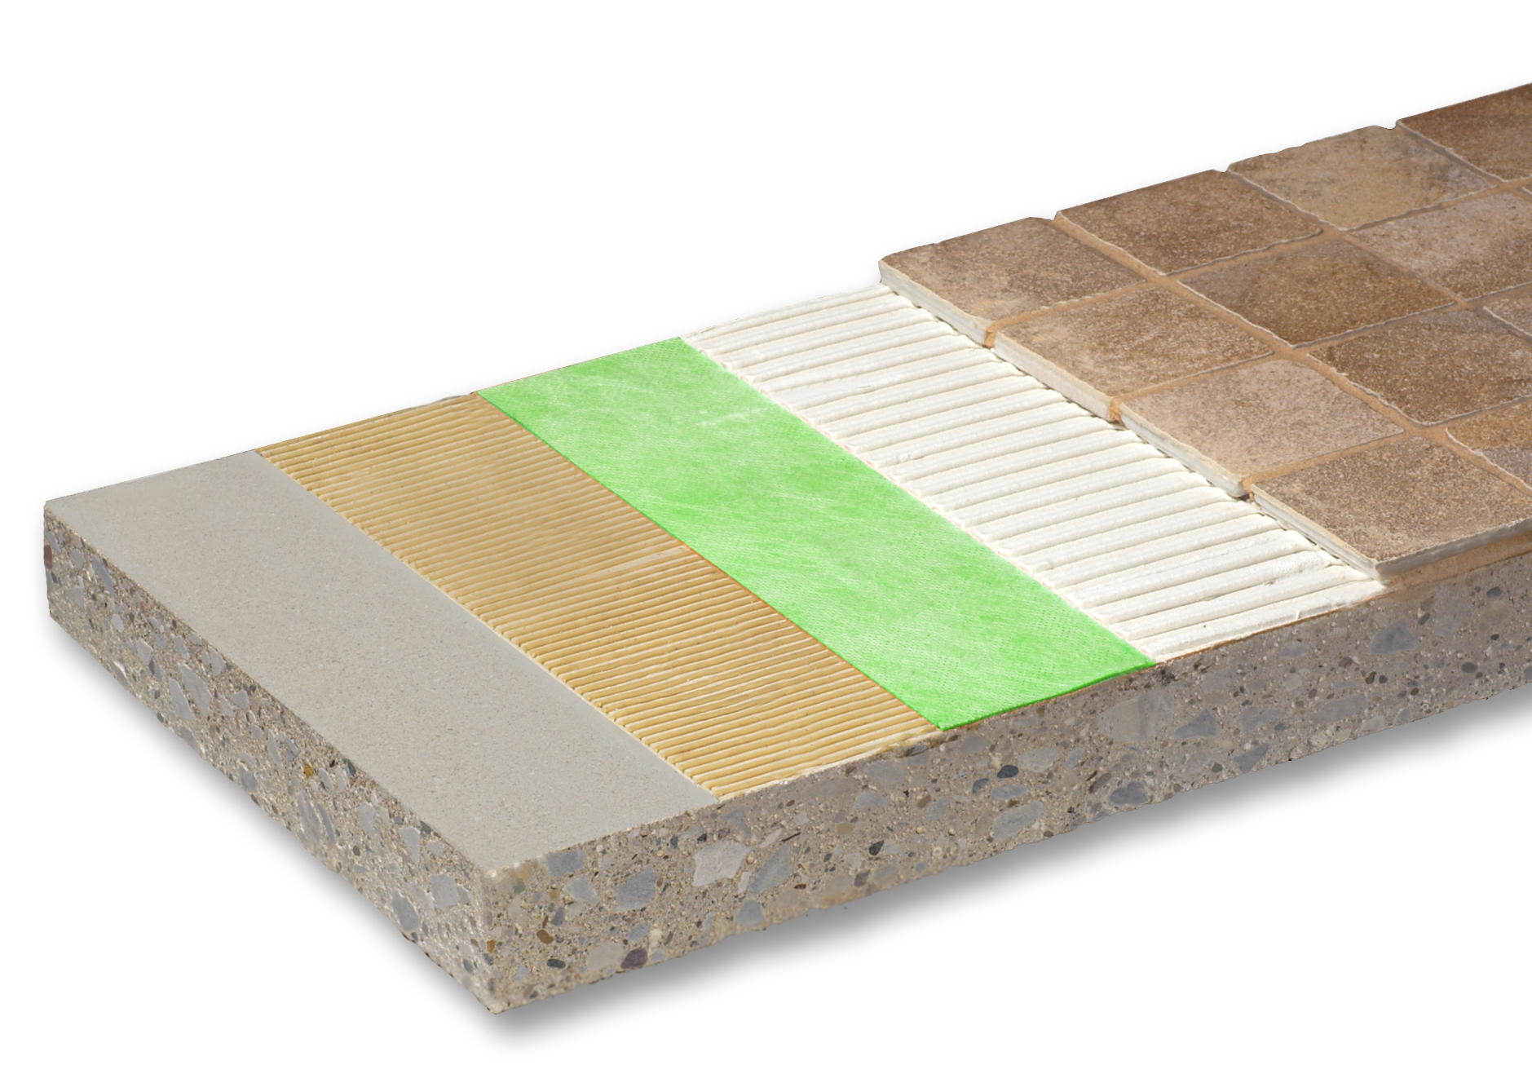
- PRODUCTS
ValueSeal
      - SHEET MEMBRANE [WATERPROOFING]
        - Sheet Membrane: ANSI A118.10; composite sheet membrane made from polyethylene (PE) with non-woven fiber laminated to both sides.
          - Basis of Design Manufacturer: Noble Company.
          - Basis of Design Product: ValueSeal.
        - Performance:
Include water vapor permeance for steam room applications. ASTM E96/E96M, Procedure E uses the desiccant method at high temperature 100 deg F (37.8 deg C) and 90% humidity.
          - Water Vapor Permeance: ASTM ASTM E 96/E96M, Procedure E; maximum less than 0.5 perms (28.6 ng/Pa•s•m²).
      - ACCESSORIES
        - Bonding Mortar:
          - Latex Portland cement mortar (Thin Set): ANSI A118.4.
        - Bonding Adhesive: Type recommended by sheet membrane manufacturer to suit application [with VOC less than LEED allowable limits].
Include NobleBond EXT for interior locations used in horizontal and vertical applications excluding steam room.
          - Basis of Design Product: NobleBond EXT.
        - Seam Sealant: Type recommended by sheet membrane manufacturer [with VOC less than LEED allowable limits].
          - Basis of Design Product: NobleSealant 150.
        - Perimeter Sealant: Type recommended by sheet membrane manufacturer [with VOC less than LEED allowable limits].
- EXECUTION
      - EXAMINATION
        - Examine [tile] [and] [stone] substrates, including [walls,] [floors,] [ceilings,] [and] [framing] for unacceptable conditions affecting sheet membrane installation.
        - Examine roughing-in for plumbing piping to verify actual locations of piping connections before sheet membrane installation.
        - Correct unacceptable conditions before installing sheet membrane.
      - PREPARATION
Floor slab moisture content may be measured by moisture emission test or by relative humidity test, or both.
        - Examine, prepare, and test concrete floors for finish flooring installation in accordance with ASTM F 710. Perform one [moisture emission test in accordance with ASTM F1869] [relative humidity test in accordance with ASTM F2170] and one alkalinity test for every 2,000 sf (185 sq m). Obtain instructions for corrective measures from flooring and adhesive manufacturers when test results are not within specified limits.
Use more restrictive substrate tolerances when installing large format tile. Verify acceptable limits with tile manufacturer.
          - Surface Tolerance: Maximum variation from plane per TCNA recommendations and ANSI standards.
            - Floor systems over which tile will be installed shall be in conformance with [IRC] [IBC] [applicable building codes].
Include moisture emission rate or relative humidity requirements, or both. When using NobleBond EXT use the following requirements. Coordinate with tests specified above.
          - Moisture Emission Rate: Maximum 4 lbs. per 1000 sq ft (1.4 kg 100 sq m) per 24 hours when tested using calcium chloride moisture test kit for 72 hours.
          - Relative Humidity: Maximum 85 percent.
          - Alkalinity Range: pH of 7.0 to 9.0.
        - When tested moisture emission rate exceeds specified maximum, consult membrane manufacturer, thin-set manufacturer and tile manufacturer for acceptable mitigation methods and materials.
      - INSTALLATION - SHEET MEMBRANE WATERPROOFING [AND VAPOR RETARDER]
Include this article when sheet membrane is installed on solid substrates including floors and tile backer boards. Include option above only when sheet membrane is installed in steam rooms.
        - Comply with ANSI A108.13, TCNA Handbook, and the manufacturer’s instructions for installation of sheet membrane waterproofing.
Include the next paragraph for thin-set floor and wall applications.
        - Bonded Installation for Thin-Set Applications:
          - Apply bonding [mortar] [adhesive] for full coverage of substrate.
          - Install sheet membrane and fully embed into bonding material.
            - A carpet type roller (75 – 100 lbs) may be used to embed sheet membrane on horizontal surfaces.
            - Hand roller or flat side of trowel can be used to embed sheet membrane on vertical surfaces.
        - Overlap sheets minimum 2 inches (50 mm) (shingle in direction of water drainage preferred). Seal joints watertight.
        - Turn sheet membrane installed on floors up vertical surfaces.
          - Shower Walls: When sheet membrane is turned up and terminated behind backer board, extend minimum 3 inches (75 mm) above flood plane and fasten to substrate with no penetrations less than 2 inches (50 mm) above flood plane.
          - When membrane is turned up in front of backer board, ValueSeal should extend to the ceiling.
        - Extend sheet membrane into floor drains. Install NobleFlex Drain Flashing to facilitate smooth transition between the clamping ring drain and the waterproofing membrane. Secure the Flashing to the drain. Seal membrane to flashing with NobleSealant 150. Seal to drain body with floor drain clamping ring.
      - FIELD QUALITY CONTROL
Include this article for flood testing floor waterproofing installations, only.
        - Upon completion of sheet membrane waterproofing installation, plug drains, dam perimeter of waterproofing and fill with water minimum 2 inches (50 mm) deep and maintain for 24 hours.
          - Inspect waterproofing for leaks.
          - Repair leaks and re-test until watertight.
        - Prepare test and inspection reports. Indicate corrective measures required to make installation watertight.
      - PROTECTION
        - Protect sheet membrane from pedestrian and vehicular traffic and prolonged exposure to sunlight.
        - Keep sheet membrane clean until [tile] [and] [stone] finishes are installed.
END OF SECTION 093000



P.O. Box 350 · Grand Haven, MI 49417-0350 · 800-878-5788 · Fax: 231-799-8850 · www.noblecompany.com
® Registered Trademark of Noble Company, Grand Haven, MI. ™ Trademark of Noble Company, Grand Haven, MI.

